# INTRODUCTION

* 1. Overview

In this project, we use custom objects, relationships, page layouts to give the HR team easy access to data they need on an existing recruitment app.

* 1. Purpose

To make the existing app more efficient for the HR team we create custom objects and relationships to store and access the data more efficiently. We install an unmanaged package in the org to get metadata that acts as existing data in the recruitment app.

1. **Problem Definition & Design Thinking**
   1. Empathy Map

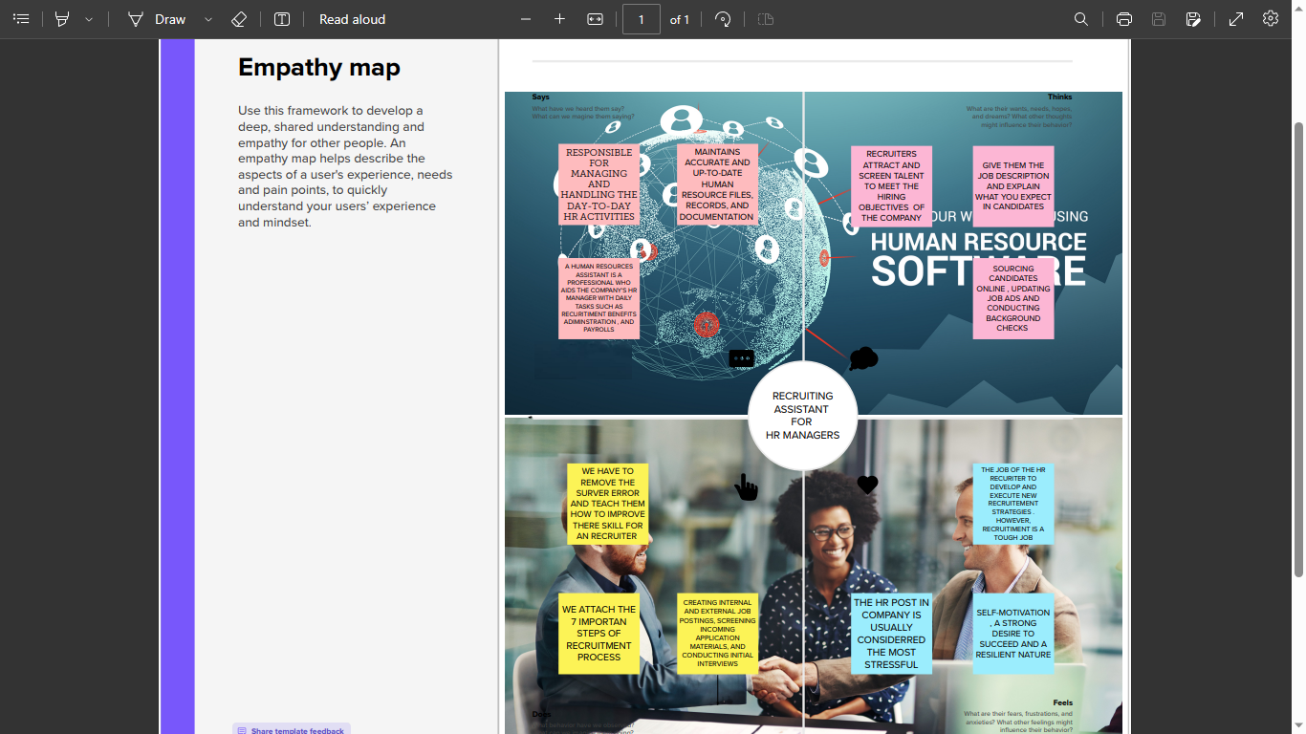

* 1. Ideation & Brainstorming Map

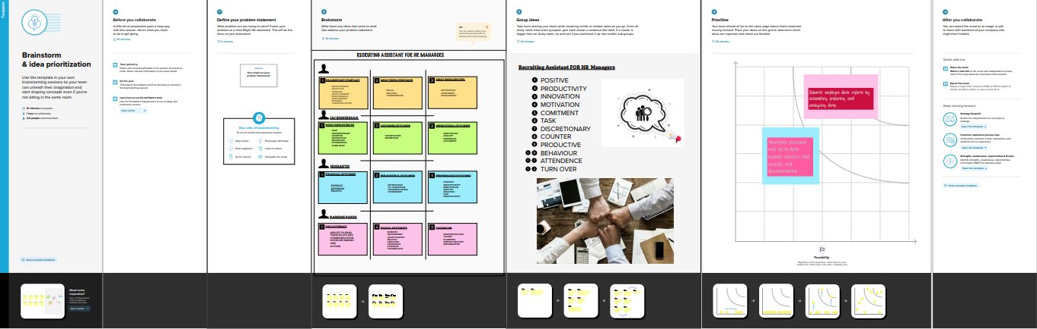

# RESULT

* 1. Data Model:

|  |  |
| --- | --- |
| Field label | Data type |
| Campaign | text |
| Leads | date |

|  |  |
| --- | --- |
| **App** | **Object** |
| Sales app |  |
| Service app |  |

# Activity & Screenshot

|  |  |
| --- | --- |
| Field label | Data type |
| Cases |  |
| Acccounts |  |

# 

# Trailhead Profile Public URL

**Team Leader ;** https://trailblazer.me/id/akumar8295

**Team Member 1 -https://trailblazer.me/id/jairishikesan**

# Team Member 2 –https://trailblazer.me/id/rktbtb32

# Team Member 3-https://trailblazer.me/id/rameshtj

1. **ADVANTAGES**

* **Less capital requirement**
* **More profit margin**
* **Credit facility**
* **Better customer relation**
* **No liability**

**DISADVANTAGES;**

* **High marketing cost**
* **Selling skill required**
* **Very high competition**
* **No economies of buying**
* **It requires proper location**

# APPLICATIONS

* Set up
* Sales
* Service
* Trailhead
* github

# CONCLUSION

# Recruitment is the overall process of identifying, sourcing, screening, shortlisting, and interviewing candidates for jobs within an organization. Recruitment also is the process involved in choosing people for unpaid roles

# Recruitment process is a process of identifying the jobs vacancy, analyzing the job requirements, reviewing applications, screening, shortlisting and selecting the right candidate.